**Lab On Inheritance, Abstract Classes and packages**

1. Implement the following inheritance:

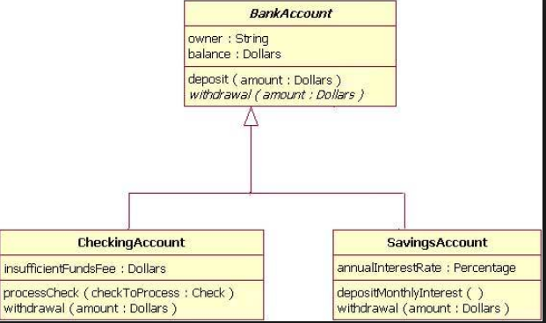

1. Create a Class Polygon with three variables l,b,h. Create a parameterised method to set the values to l,b,h. Create an abstract method compute().

Create a subclass of Polygon as Cuboid and implement the method compute(). Create an another subclass of Polygon as Cube and implement compute(). Write a method to display the computed information in both the classes

1. Create a class A with the two variables x and y. Create a parameterised method to set the values. Write abstract methods sum() and display().

Create two subclasses B and C with a variable in each of the class. Create constructors in the subclasses. implement sum of three numbers in each class and display the information.

Create an abstract class A with an abstract method display(). Create a subclass B and implement display() function and print "this is it". Create a subclass C and override display() and print "this is in class c". Create a subclass D and override display() and print "this is in subclass d". Create a main function to call all the display methods.(Do not use super keyword, use Dynamic Method Dispatch or runtime polymorphism)

1. Create a class Library with the variables bno,bname and bprice. Set the values to the variables using a parameterised method. Create an abstract method updatePrice() and abstract method display().

Create a subclass ItLibrary with the variable deptname. Create a parameterised constructor to set the deptname. Create a getBookDetails() to display the information.

Create a main function to print this.

1. Create a class A with a method show(). Create a subclass B and implement show() method. Create a subclass C to the class B and implement show(). Create another subclass C and Implement show().

Create a main method to access all the show() methods.

**(One solution is to use base.method() in all the subclasses**

**Other solution is do it the following in the main method.**

**Create a variable to the base class as A object1;**

**Create objects to all the classes A ob1=new A(),B ob2=new B(),C ob3=new C().**

**Now assign object1=ob1 and call object1.show().**

**Now assign object1=ob2 and call object1.show().**

**Now assign object1=ob3 and call object1.show().**)

1. Create an abstract class Accounts with balance, accountnumber, accountholdername, address. Create abstract methods deposit() and withdraw(). Create a method display() to show the balance of the account number.

Create a subclass of this class SavingsAccount with a variable rateofinterest. Create claculateAmount(). Create display() to display the rate of interest with new balance and full account holder details

Create another subclass CurrentAccount with overdraftlimit. Crate a display() method to show overdraft limit along with the full account holder details.

Create object of the two classes and call their methods.

1. Create a program to implement virtual functions